**Suppliers+ Inventory**

Ali Abass: 212922553

Maged natour : 212066260

Lana farraj : 324917293

Mohamd assi : 322715871

1)**Use Case:**

**A:**

d – adding a new supplier:

c – updating stock and shortage warning:

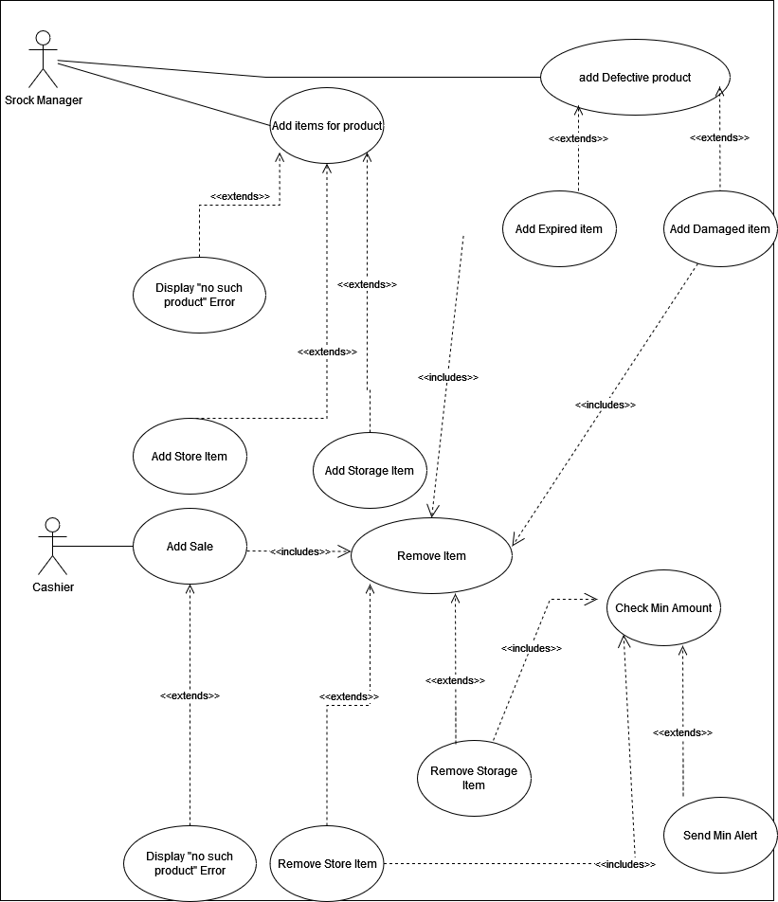

e - Placing a periodic order:

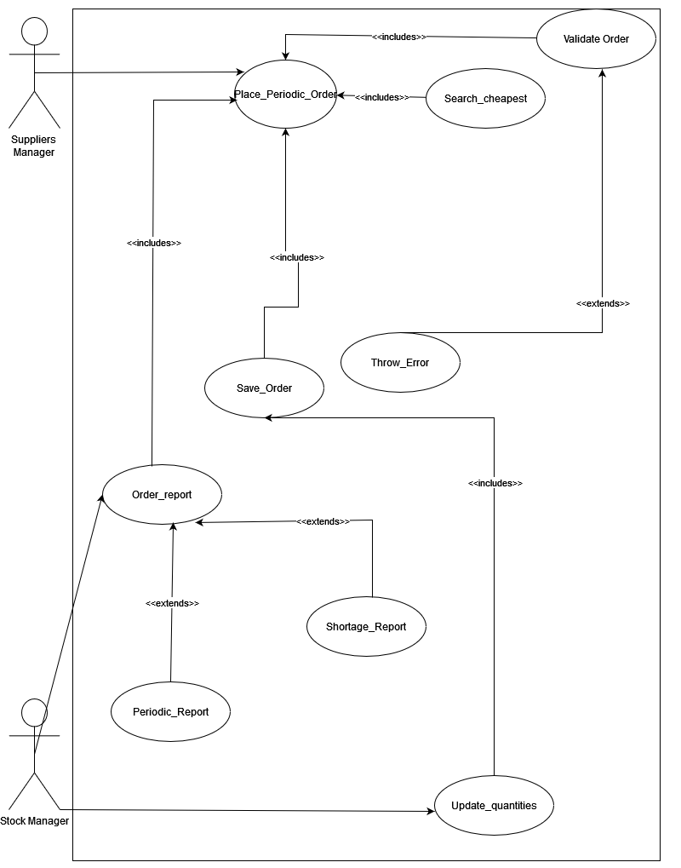

f - Placing a shortage order:

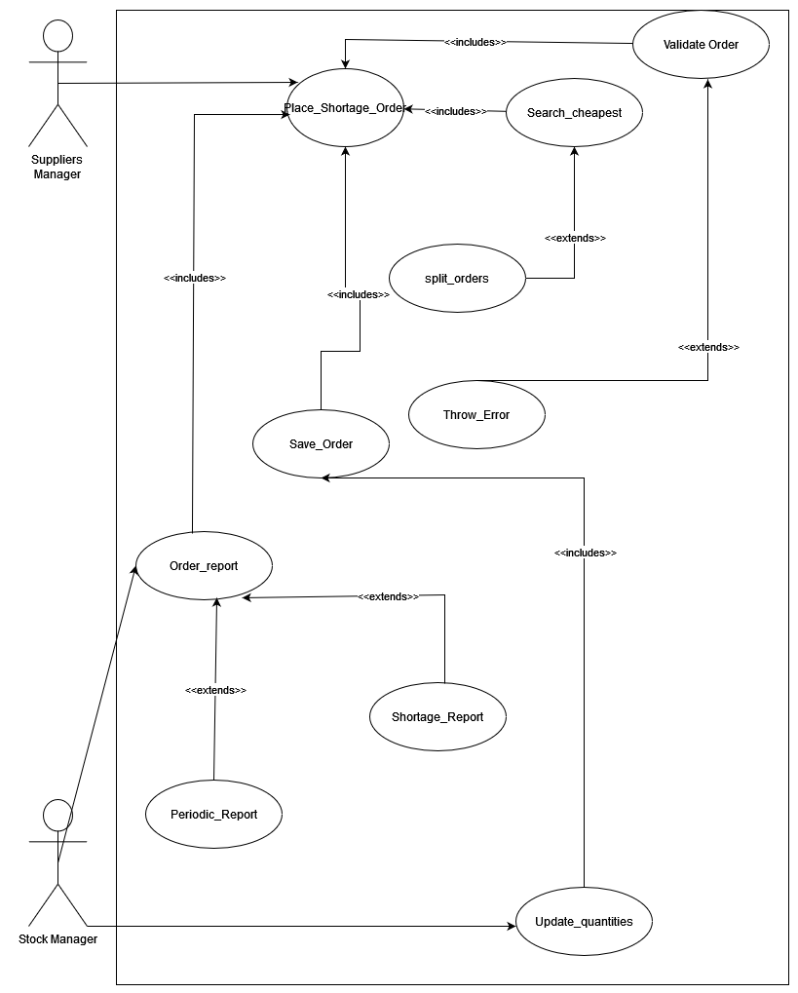

a+b+g+h:

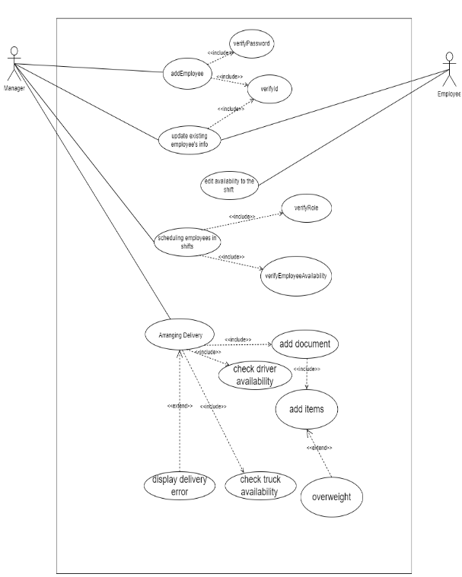

**B:**

|  |  |
| --- | --- |
| Use case name | Placing a periodic order. |
| Textual Description | This use case represents an action of placing an order in a fixed time . |
| List of Actors | Suppliers manger and Stock manger. |
| Pre-conditions | The order must be updated at least a day before or an there is an existing order that we will order again.  There must be a contract with the supplier.  The stock manger must have provided an items report or updates an existing periodic order  at least one day before the delivery. |
| Post-conditions | A successful message will be shown.  The order is saved in the order history.  If the order hasn’t been updated in the next week we will use this week’s order. |
| Main success scenario | -The suppliers manger validates the report.  - The suppliers mangers find the cheapest provider for the corresponding report.  -The order is saved in the system.  -The stock manger updates the quantity accordingly. |
| Alternatives/Extensions | -The suppliers mangers tries to find the best deal for the report , If there is no supplier that can provide the order an error should be displayed.  -The suppliers mangers receives the order report ,if there is a mistake in the provided order report an error will be displayed. |

|  |  |
| --- | --- |
| Use case name | Placing a shortage order. |
| Textual Description | When the manager gets a warning from the system that an item has reached its minimum amount, he has to make a new order and he has to set the amount to order at least as the minimum amount of the item |
| List of Actors | Suppliers manger and Stock manger. |
| Pre-conditions | There must be a contract with the supplier.  The item stock amount has to be in defined shortage amount. The stock manger gets a warning for the items that reached the minimum amount. |
| Post-conditions | A successful message will be shown.  The order is saved in the order history.  If there is multiple suppliers that can provide the order the cheapest will be chosen.  If there is not a single supplier that can provide the order the order will be split and we will choose the cheapest division. |
| Main success scenario | -The stock manger provide an order report .  -The suppliers manger validates the report.  - The suppliers mangers find the cheapest provider for the corresponding report.  -The order is saved in the system.  -The stock manger updates the quantity accordingly. |
| Alternatives/Extensions | -The suppliers mangers tries to find the best deal for the report , If there is no supplier that can provide the order an error should be displayed.  -The suppliers mangers receives the order report ,if there is a mistake in the provided order report an error will be displayed.  - The suppliers mangers tries to find the cheapest deal for the report If there is not a single supplier that can provide the order , the order will be split and the system will choose the cheapest division. |

